**Linux File Hierarchy Structure (FHS):**

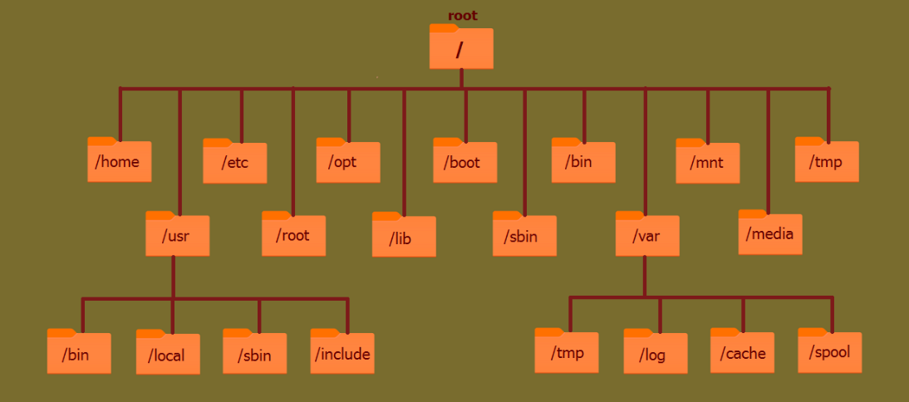

The **Linux File Hierarchy Structure (FHS)** organizes files and directories in a logical tree. Below is a brief explanation, followed by a diagram:

**Key Directories in FHS:**

1. **/**: Root directory; base of the filesystem.
2. **/bin**: Essential binaries for all users (e.g., ls, cp).
3. **/sbin**: System binaries for administrators (e.g., reboot, fdisk).
4. **/etc**: Configuration files for the system and applications.
5. **/home**: User directories (e.g., /home/user).
6. **/var**: Variable files (e.g., logs, spool files).
7. **/usr**: User applications and utilities.
8. **/tmp**: Temporary files, cleared on reboot.
9. **/boot**: Boot loader files (e.g., kernel, GRUB).
10. **/lib**: Essential libraries for binaries in /bin and /sbin.
11. **/opt**: Optional software packages.
12. **/dev**: Device files (e.g., /dev/sda).
13. **/mnt** and **/media**: Mount points for external devices or temporary filesystems.
14. **/proc** and **/sys**: Virtual filesystems providing system and process information

**1. / – Top-Level Directory**

The / (root directory) is the base of the Linux file hierarchy. All files and directories are located under it, including system files, applications, and user data. This structure ensures everything on the system is well-organized under one root.  
Example:

cd / ls /

**2. /root – Root User’s Home Directory**

/root is the home directory for the system's administrator (root user). It’s separate from other users' home directories, which are found in /home.  
Example:

cd /root ls /root touch /root/example.txt pwd

**3. /bin – Essential User Binaries**

Contains crucial binaries like ls, cp, and cat, needed for basic system operation. These commands are available to all users.  
Example:

ls /bin /bin/ls

**4. /boot – Boot Loader Files**

Stores files required to boot the operating system, such as the Linux kernel and bootloader configurations (e.g., GRUB).  
Example:

ls /boot cat /boot/grub/grub.cfg

**5. /dev – Device Files**

Holds files representing devices like hard drives and terminals. For example, /dev/sda for the first hard disk.  
Example:

ls /dev cat /dev/null

**6. /etc – Configuration Files**

Contains system-wide configuration files for applications and services. Modifications here adjust system behavior.  
Example:

ls /etc cat /etc/passwd

**7. /home – User Home Directories**

Each user gets a personal directory under /home to store files and settings, e.g., /home/user.  
Example:

cd /home ls /home cd /home/username

**8. /lib – Essential Shared Libraries**

Stores libraries required by binaries in /bin and /sbin. These libraries enable core system functionality.  
Example:

ls /lib ldd /bin/ls

**9. /media and /mnt – Mount Points**

* /media: For automatically mounted devices like USB drives.
* /mnt: For temporary manual mounts (e.g., network shares or ISO files).  
  Example:

ls /media ls /mnt mount /dev/sdb1 /mnt

**10. /opt – Optional Software**

Holds third-party or optional software packages, keeping them separate from system-installed applications.  
Example:

ls /opt

**11. /sbin – System Administration Binaries**

Stores administrative commands like fdisk and reboot, primarily for the root user.  
Example:

ls /sbin /sbin/ifconfig

**12. /usr – User Utilities and Applications**

A large directory containing user-installed applications, documentation, and utilities. Subdirectories include /usr/bin and /usr/share.  
Example:

ls /usr ls /usr/bin

**13. /var – Variable Data Files**

Houses files that change frequently, like logs (/var/log), caches, and spooled files.  
Example:

ls /var cat /var/log/syslog